Service Directory

Community Living South Muskoka
Head Office: 15 Depot Dr., Bracebridge, ON P1L 0A1
Tel: 705-645-5494 Web: www.clsm.on.ca
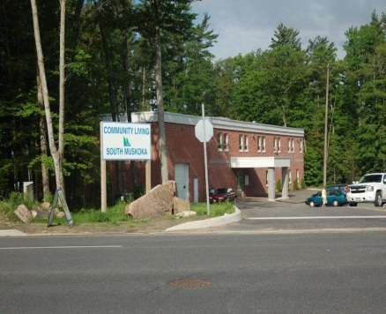

Contents
Our History | 3
Our Leadership Team | 5
Organizational Chart | 6
Service Area | 7
Goal and Vision Statement | 8
Guiding Principles | 9
Children's Services | 10
Adult Services | 17
Eligibility and Admission for Services | 23
Planning | 30
Quality Assurance Compliance | 33
Appendices | 44

Our History
Founded in 1960 by a group of concerned parents and incorporated in 1967, Community Living South Muskoka is a registered charity that provides support to over 400 individuals with a developmental disability and their families.

In 1961, the Bracebridge United Church offered their facilities to provide a classroom for the Association to use towards fulfilling their goals. Two teachers were hired and willing volunteers recruited to help where needed. A Building Committee, formed in 1962, raised the necessary money to build a new school to meet the children’s needs. After much work and a lot of planning, this was finally accomplished and on October 17, 1968, the new school, known as Victoria Street School, was officially opened. The Board of Education took over the operation of this school. The programs became diversified and a good deal of progress was to be seen. With younger persons needs being looked after, the Association refocused its attention on the adults and thus began the work of opening an Adult Workshop. A.R.C. Industries, provided work-related programs and remained in full operation until 1992. This was replaced by the Community Skills Development programs.
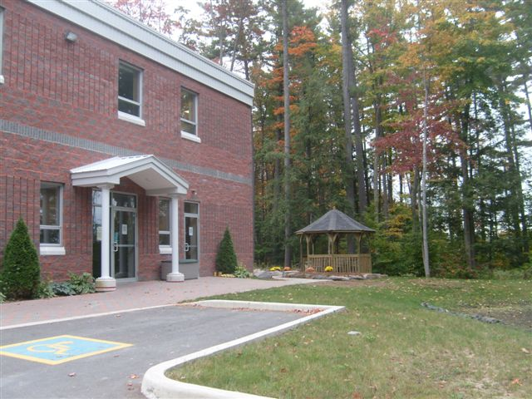
In 1986, the Family Support program was transferred from the Children’s Aid and the Resource Teacher program was initiated. The Respite program was formed in 1987 to provide respite to caregivers. This program has since expanded to provide respite for children & adults.

In 1988, the Association opened their first Residential program and this service continues to expand and grow. In February 2002, a group home was opened in Port Severn to provide support to the west side of our territory. 2002 also saw the commencement of services for Transition Aged Youth through the Youth Works program. In 2007 and 2009 two group homes were opened and we welcomed 6 individual as the last facilities in the province closed their doors. In 2010, we sold one of our original group homes in Bracebridge and opened a triplex for individuals to live in their own apartments in the community who need more support than our traditional Supported Independent Living Program provided. In 2012, Community Living South Muskoka closed a rental apartment in Gravenhurst and our century old group home in Bracebridge was put up for sale. We purchased a new home in Bracebridge to better suit the needs of the people we support.
Community Living South Muskoka believes that the Government of Ontario will never have enough resources to meet the needs of the developmentally disabled. We must find other ways to financially sustain ourselves and become a valued contributing member of our community. With this goal in mind Community Living South Muskoka purchased a 35 acre farm on the outskirts of Bracebridge in 2007 called Morrison Meadows. We wanted to create employment opportunities for the individuals we serve, and become an outdoor recreational space for our community to enjoy and see individuals with a developmental disability as capable, friendly, teachers, partners and community leaders. The cost of this project is not funded by the Ministry.

With the funds raised in our community over the past few years we have constructed a barn, enhanced our parking, built a children’s play area that includes a 3 wheel bike race track, potato sling, a train, installed a solar array to sell power back to Ontario Power Generation and developed 10 community garden beds. We have also partnered with the District of Muskoka and have developed 7 kilometers of trails for walking, hiking, cross country skiing and snowshoeing. We have also worked with our local farmers and have grown corn and pumpkins for the past two years.

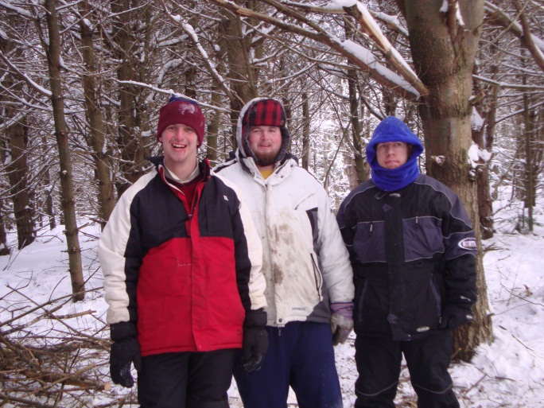
Every September we host our annual Fall Harvest Days. The event is open to the community to enjoy a day at the farm, participate in games and activities, campfires, wagon rides and pick their own pumpkins. Community Living South Muskoka also opened the farm to local kindergarten classes to enjoy the activities at the farm and pick their own pumpkins. We have also partnered with the schools to host the Muskoka Mud Run at the farm where 1,200 school children and their families enjoyed a day of fun, competition and activities. During the winter months we operate Snowdrifts which teaches local school children winter survival skills and snowshoeing. Community Living South Muskoka staff and the developmentally disabled individuals we employ show children how to build quinzees, start a campfire without matches, and enjoy the trails on the farm.

Our Leadership Team
Community Living South Muskoka is governed by a volunteer Board of Directors. The strength of Community Living South Muskoka’s leadership starts at the top with a committed chair leading a board composed of independent, well-informed directors, who give priority to the strategic vision of the organization and seeks continuous improvement of the services provided to individuals and their families and a proactive customer focused management team. Our team consists of:

Board
Gord Haugh, Chair
Lang Moffat
Linda O’Hallarn
Bruce Hemphill
Gordon Larock
Elaine Scriven
Ryan Griffiths
Linda Davidson

Chief Executive Officer
Krista Haiduk-Collier

Administration
Kelly Miles, Chief Financial Officer
Gene Greenhalgh, Chief Operations Officer
Colleen Kelly-Berrichi, Director Accommodation Services
Cathy Meyer, Director Services and Supports
Heather Greer, Supervisor Human Resources & Centralized Scheduling

Accommodation Services
Gene Greenhalgh, Chief Operations Officer
Colleen Kelly-Berrichi, Director Accommodation Services
Aleisha Burta, Supervisor Services and Supports
Lorie Vogels, Supervisor Services and Supports
Dawn DeCaire, Supervisor Services and Supports
Kelly Cleland, Supervisor Services and Supports
Debbie Southorn, Supervisor Services and Supports

Children’s Services
Gene Greenhalgh, Chief Operations Officer
Cathy Meyer, Director Services and Supports
Lynn Dennys, Supervisor Planning, Quality Assurance and Children’s Services

Community Participation and Employment Services
Gene Greenhalgh, Chief Operations Officer
Cathy Meyer, Director Services and Supports
Debbie Southorn, Supervisor Services and Supports

Passport Services
Gene Greenhalgh, Chief Operations Officer
Cathy Meyer, Director Services and Supports
Kelly Cleland, Supervisor Services and Supports

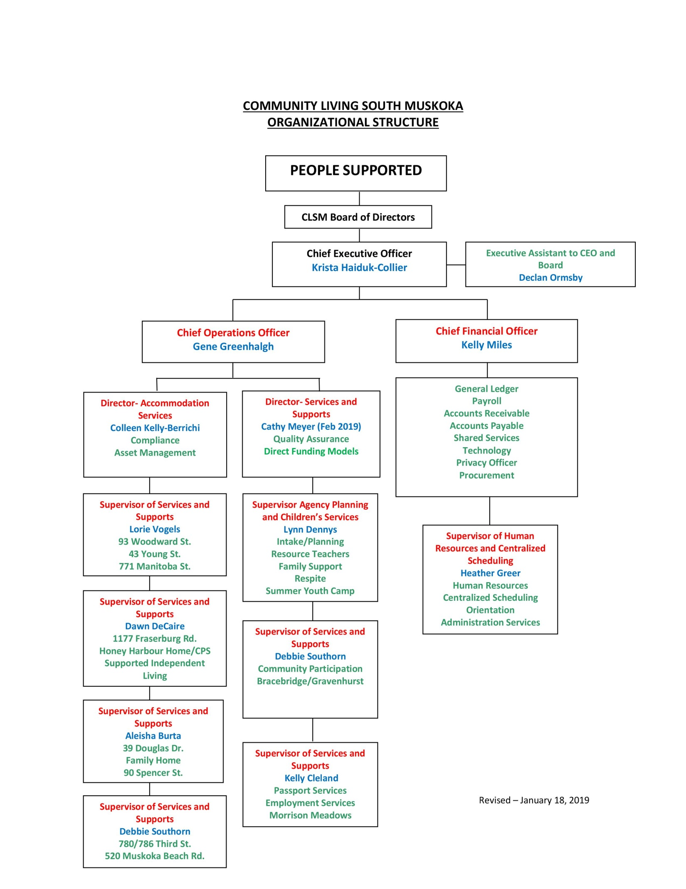

Service Area
Community Living South Muskoka serves individuals residing in South Muskoka from Severn Bridge and Port Severn/Honey Harbour to the South and from Mactier to midway between Bracebridge and Huntsville in the North. For respite services and Family Home programs we support individuals in the entire District of Muskoka.

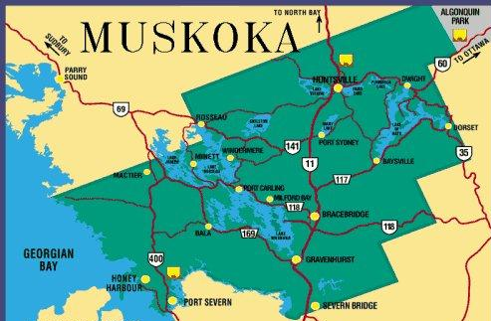

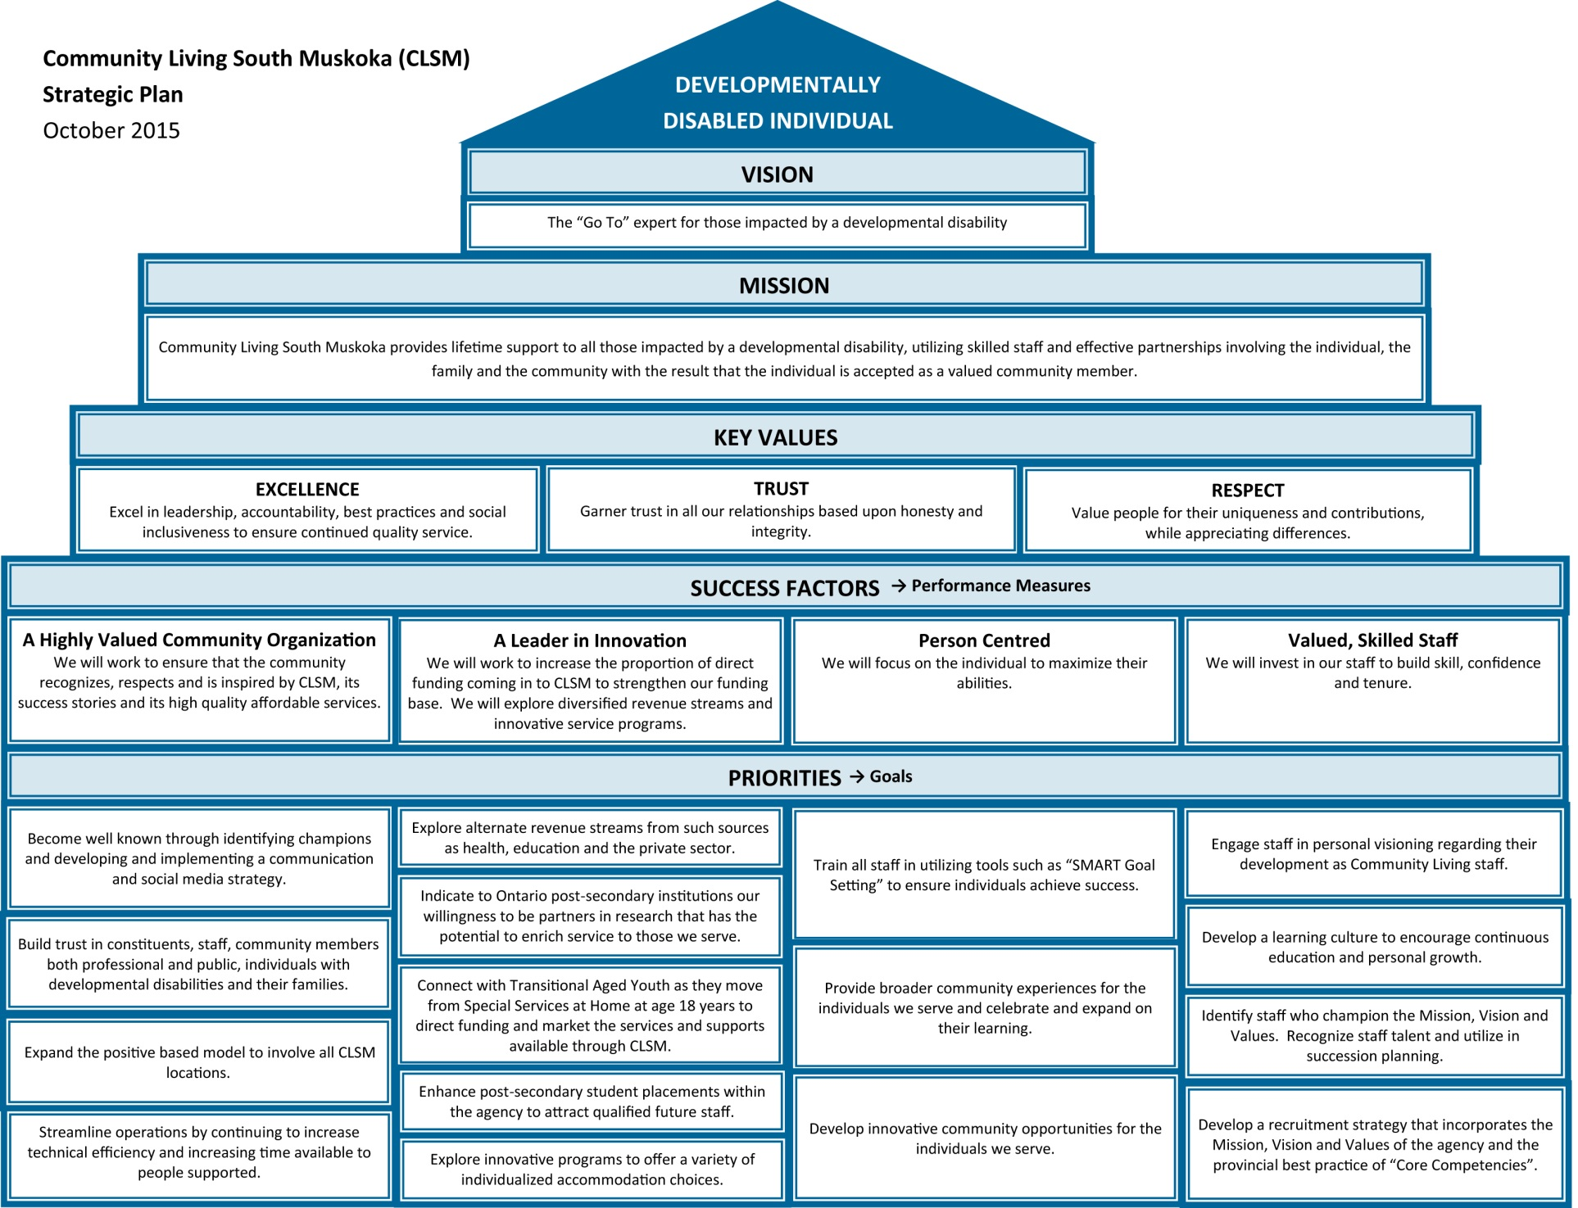

Resource Teacher Program
Our mandate is to serve children two (2) to six (6) years of age who have one or more delays or are at risk of delay in any of the following areas: motor development (fine and gross motor); language development (expressive and receptive); cognitive development; social, emotional, or self- help areas of development. Children must be either attending or willing to attend a licensed pre-school setting or an Ontario Early Years Center (drop-in), or be enrolled in Junior or Senior Kindergarten.

Children with special needs are enrolled and integrated into community pre-school programs with the help of the Resource Teacher. The Resource Teachers also provide transitional supports to children with special needs who are enrolled in Junior or Senior Kindergarten. The Resource Teacher also visits the child and family in their home to share strategies and programming goals that are imperative for the child’s early development in collaboration with clinical services..

The Resource Teacher acts as a case manager with the family and assists the family in accessing services for the child: school, speech therapy, occupational therapy, physiotherapy, behavioural services, medical services, etc. They also assist the family in accessing financial supports available to them for their child: Assistance for Children with Severe Difficulties, Special Services at Home, Assistance Devices Program, Easter Seals, Respite Services, Daycare Subsidy, Child Care Program Assistants.

The Resource Teacher assists families in integrating their children with special needs into licensed community pre-school programs and:
• Designing appropriate programs to meet the child’s specific developmental needs.
• Connecting community services and supports.
• Obtaining appropriate funding when applicable.
• Works as part of a multi-disciplinary team often consulting with other community partners.
• Advocating and promoting the philosophy of integration.

CCPA
Community Living South Muskoka works in cooperation with Community Living Huntsville, the District of Muskoka and the Licensed Childcare community to provide Childcare Program Assistant (CCPA) funding in South Muskoka. The CCPA funding process is available to all licensed child care programs in Muskoka. It is designed to support Muskoka’s commitment to welcome all children and support family choice.

The funding is available for children birth to 12 years. It is designed to respond to an expressed need by the childcare community. It is short term in nature, and designed to be an ‘extra pair of hands’ in the childcare setting, to provide opportunity for the Educator to meet the special needs of children as identified. Support is provided by the Resource Teachers to work with the team to develop strategies which support the fading out of the CCPA whenever possible.

Community Living South Muskoka currently has three (3) fulltime Resource Teachers and four(4) part-time Resource Teacher Assistants. The office of the Resource Teacher program is located at 15 Depot Drive, Bracebridge, Ontario and we currently provide support in the following Pre-school and School settings:

Child Care Centres | Elementary Schools
Gravenhurst Children’s Place | Muskoka Falls Public School
YMCA-Muskoka Falls | Macaulay Public School
Bracebridge Children’s Place | Monsignor Michael O’Leary Catholic School
Ontario Early ON Programs | Bracebridge Public School
Lodestar Montessori School | Monck Public School
Muskoka Lakes Preschool | Watt Public School
Bracebridge Public School Children’s Place | Honey Harbour Public School
Macaulay Tree House | Glen Orchard Public School
Biinoji House | Gravenhurst Public School
 | KP Manson Public School
Our Lady of Mercy Catholic School
Mactier Public School
Muskoka Beechgrove Public School

Family Support
The Family Support Program is designed to support families with children aged three to eighteen years that are developmentally disabled, to access and co-ordinate supportive resources.

Family Support Workers in conjunction with the family provides emotional support, empowerment and advocacy. The Family Support Worker will assist in the development of individuals family support plans and help establish transition goals.

Resource Co-ordination may include:
- Identifying and assisting families with referrals to appropriate services including:
- Pediatric, behavioural, mental health, autism, occupational or physical therapy, speech
- School advocacy
- Assist families with the transition process from home to school
- Support families in learning their role on the education team
- Assist families with school meetings, ideas with communicating areas of concern, individual Placement Review Committee (IPRC) and Individual Education Plan (IEP).
- High School to Adulthood Transition
- Offer support and information to both students and families on transitioning from school to adulthood
- Assist student, families and school personnel with transition planning
- Assist families with referrals to Developmental Services Ontario (DSO)
- Family Education
- Provide families with educational resources which pertain to their child’s disability
- Mentor families to be role models to other families with children with a disability
- Assist families with making referrals and completing applications to a variety of financial assistance supports

The Outreach component is designed to provide support to families in remote areas of the district who may not otherwise have access to services.

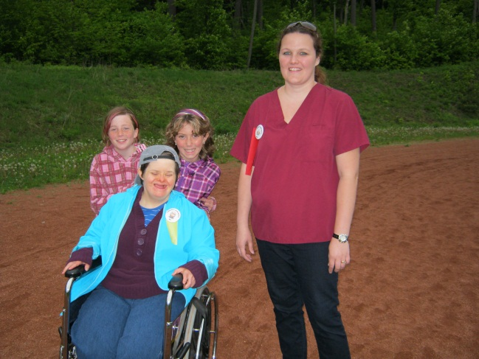
Community Living South Muskoka has three (3) full time Family Support Workers, one supporting individuals who are attending high school, one supporting elementary school aged individuals and their families in the Gravenhurst and surrounding area and West Muskoka, and the other staff supporting elementary school aged individuals and their families in the Bracebridge and surrounding area. The offices of the Family Support program are located at 15 Depot Drive, Bracebridge, Ontario and we currently provide support in the following School settings:

Elementary Schools | Secondary Schools
Muskoka Falls Public School | Bracebridge and Muskoka Lakes Secondary School
Macaulay Public School | Gravenhurst High School
Monsignor Michael O’Leary Catholic School | St. Dominic’s Catholic High School
Bracebridge Public School | Midland Secondary School
Monck Public School | Parry Sound High School
Watt Public School
Honey Harbour Public School
Glen Orchard Public School
Gravenhurst Public School
KP Manson Public School
Our Lady of Mercy Catholic School

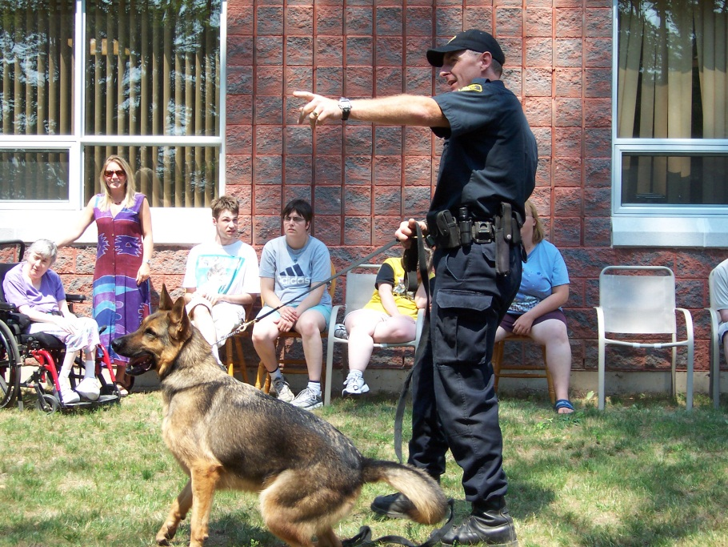

Respite Services
Respite Services are designed to provide the primary caregiver of a child with special needs with a break from caregiving responsibilities. Respite is different from daycare or traditional childcare in that it is not intended to provide opportunity for a parent to go to work. Respite is provided on a short term intermittent basis because the parent needs a break from caring for their child. It can take place in a variety of settings, and is flexible in time from hours to overnight breaks.

Families can determine how they prefer respite to be provided from the array of respite options available. Community Living South Muskoka will support families to complete funding applications, provide potential screened Respite Contractors for families to ‘contract for respite service’, help families to complete a respite plan and reimburses families for their respite costs through the funding allocated through the common application process.

The North East Region adopted a common respite funding model for children’s services. Families will complete a common application package which will be used in a common assessment process. Common eligibility guidelines have been established for the North East Region.

North East Region Respite Application Process
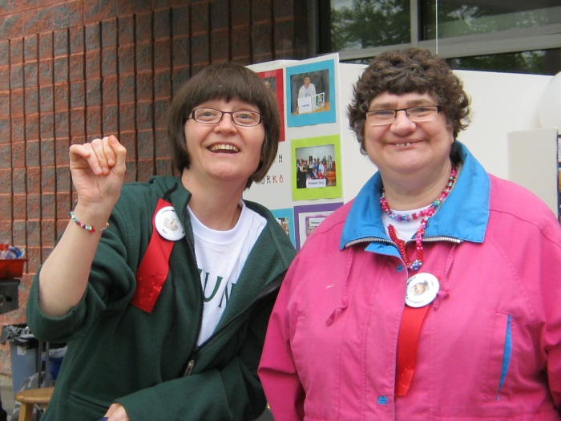
Each fiscal year, Community Living South Muskoka will provide eligible families with the common respite application. Community Living South Muskoka will assist families to complete the application if requested. Families will return the application to Community Living South Muskoka who will review the application to ensure it is complete. Community Living South Muskoka will then forward the completed respite application to the assessors.

Common Assessment Process
The applications will be assessed using a Common Assessment Tool. The result of the assessment and the amount of respite funding available will determine the amount of funding that each family receives. The assessors will communicate the respite allocation to Community Living South Muskoka who notifies the family of the funding decision. Families will invoice Community Living South Muskoka when respite is used. Invoices are to be submitted by the 15th of the month and the payments will be processed and available from Community Living South Muskoka on the 25th of the month. Community Living South Muskoka will provide on-going respite planning support as required.

Respiteservices.com
www.respiteservices.com website is an online provincial resource for families, individuals, respite contractors and professionals seeking information and links to respite services in area which they reside. It is a network of respite service agencies, located across the province of Ontario, hosting area portals within the website. The website features help to connect families to respite contractors who are interested in providing respite care and facilitates the connection to respite options for individuals, which match their identified needs. Respite contractors, families and professionals can find information on various training opportunities too. The website and portal is intended for all types of respite (infant to seniors) through the lifespan depending on the area which you reside.

The Respite Coordinator’s office is located at 15 Depot Drive, Bracebridge and the Resource Teachers and Family Support Workers assist families to complete the applications and develop respite plans.

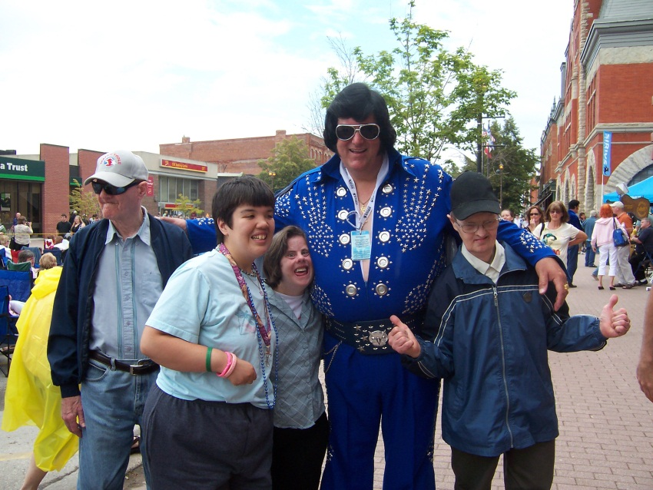

Community Participation and Employment Supports
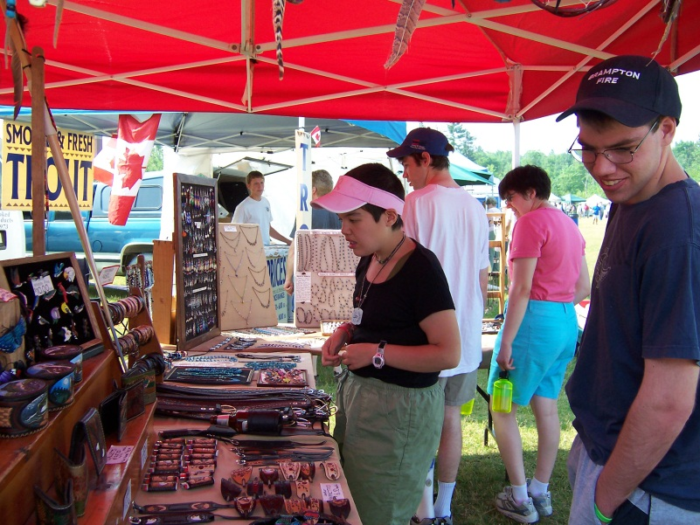
The vocational programs are designed to assist each individual who is 18 or older in experiencing community involvement through daily living, education, recreation, leisure, volunteer, training opportunities and employment experiences.

Community Participation
Community Participation is a part-time service expected to promote and enhance skill building in individuals with a developmental disability. The focus is a self-directed approach incorporating a person’s interests, needs and personal goals. The vision of Community Participation is that everyone will have community involvement based on individual choice. The goal is to promote social inclusion, independence and rights.

A range of skill development opportunities are offered to meet the individual’s needs, interest, capabilities, right of choice, and that assist in addressing the goals and objectives established through person directed planning and the individual support plan. The activities may access the local community or be centre based. Experiences include participating in existing community recreation, leisure and volunteer opportunities of the individual’s choice.

Community Participation services are offered in three (3) communities in South Muskoka and support one hundred and ten (110) individuals as follows:

Bracebridge 15 Depot Drive
Gravenhurst Unit 2B, 685 Muskoka Rd N
Honey Harbour/Port Severn 290 Muskoka Road 5 (also known as Honey Harbour Road)

Employment Services
Advances the training and employment options within their communities for adults with developmental disabilities. Employment services are market driven and encompass planning, assessment, training and skill development leading to competitive employment with natural supports.

Job coaches support individuals in obtaining employment and provide one to one assistance while the individual learns the tasks required on the job site. Supports are time limited and will be determined with the employer and the individual’s support network.

The Employment Services offices are in Gravenhurst at Unit 2B 685 Muskoka Rd N, and support individuals in both Bracebridge and Gravenhurst.

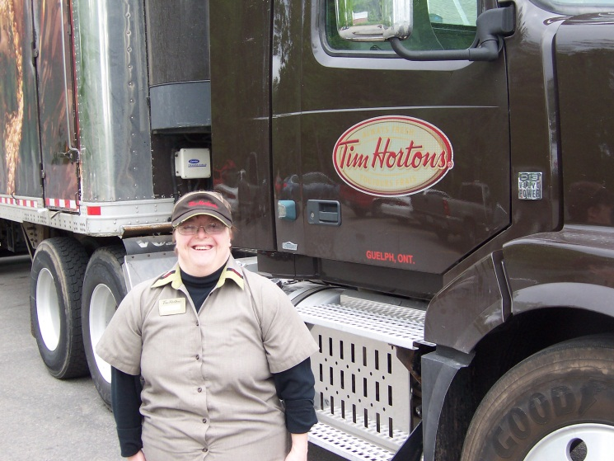

Accomodation Services
Community Living South Muskoka operates a number of accommodation services and options to ensure that individuals have appropriate homes that they are able to call their own. Community Living South Muskoka staff provide support and training to assist people to live in the community and to become as independent responsible citizens as possible.
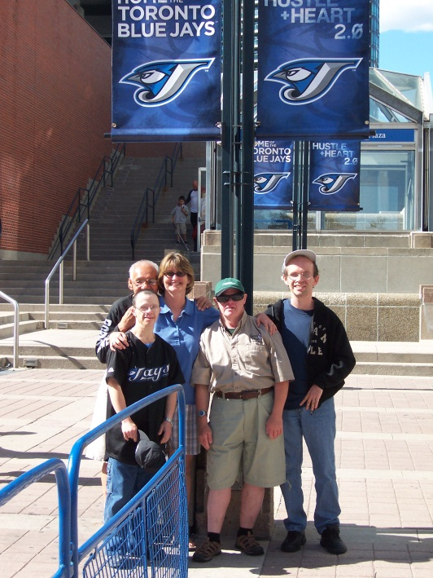
The current accommodation services offered are:

Group Homes
- are a staff-supported residence in which three or more people with developmental disabilities reside and receive supports up to twenty-four (24) hours a day. Supports include:
  - Supports to develop, review and implement an individual support plan (ISP);
  - Provision of food and other residential supports (e.g. bedding, linens, furnishings, personal care items);
  - Supports for activities of daily living such as assisting a person with personal hygiene, dressing, grooming, meal preparation, administration of medication, and includes training related to money management, banking, using public transportation and other life skills;
  - Supports for participation in community activities;
  - Supports for maintaining personal relationships and family connections, as desired; and
  - Providing for the health and safety of individuals.

Community Living South Muskoka has nine group homes that support forty-nine individuals with varying levels of support needs and are located as follows:
Bracebridge
- Manitoba Street
- Douglas Drive
- Woodward Street
- Young Street
- Fraserburg Road
- Spencer Street
Gravenhurst
- Muskoka Beach Road
- Third Street
Port Severn/Honey Harbour
- Muskoka Road 5

Enhanced Supported Independent Living
- provides support to three (3) individuals in a duplex with three separate living areas who require minimal daily support and provide opportunities for self-directed independent living.

Supported Independent Living
- provides support to seventeen (17) individuals with developmental disabilities that reside alone or with others but independently of family members or of a caregiver. Support provided is self-directed and ideally can be up to seven (7) hours per week, per individual and may include activities of daily living such as assisting a person with personal hygiene, dressing, grooming, meal preparation, administration of medication, and includes training related to money management, banking, using public transportation and other life skills.

Family Home
The Family Home Program provides support to eighteen (18) adults and children with developmental disabilities (homesharers) who have chosen to live within a family setting by:
  - Selecting and training reliable FAMILY HOME PROVIDERS and RELIEF PROVIDERS.
  - Matching individuals with families.
  - Providing financial reimbursement.
  - Promoting family and community unity.
  - Providing assistance to find appropriate services to meet individual needs.
  - Providing assistance to the Homesharer in establishing and reaching personal goals.

It is the goal of the Family Home Program to provide all adults and children with developmental disabilities with a supported integrated, yet independent living option – that is, the opportunity to live as part of a family in their own community.

Adult Respite
Adult respite is available to families who care for individuals 18 and over with a developmental disability, with or without a physical disability, by assisting them to arrange for a short break from the full time responsibility of care giving. The service is designed to give families the freedom to personally arrange respite time that is convenient, flexible, and responsive to their family’s needs. It may be used by the hour, by the day, over a weekend, or weekly blocks of time.

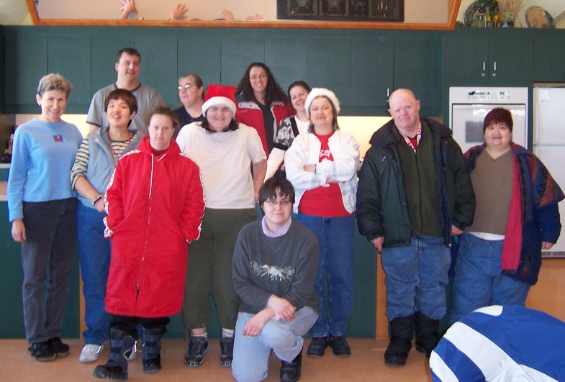
Each individual is eligible for up to six days semi-annually and is cost shared between the family and Community Living South Muskoka. We encourage all families to plan for six months at a time. Our fiscal year begins April 1 and ends on March 31. Applications are sent out on a semi-annual basis and entitlements reviewed on the information provided. Not all requests can be met automatically because of budget limitations or difficulty in locating an appropriate care provider.

Respite is considered to be a paid volunteer position. Parents are expected to pay the provider directly. The current rate given to providers is $60.00 per day or $8.95 per hour. Community Living South Muskoka will provide up to $50.00 per day or $7.46 per hour towards this cost.

Eligibility for Services
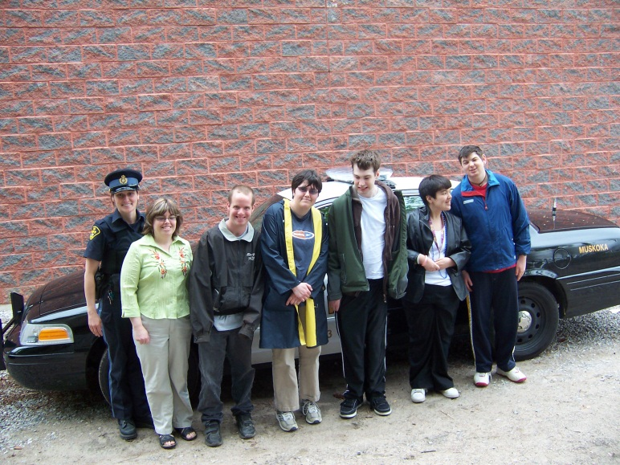
No person will be refused service on the basis of race, sex, colour, ancestry, place of origin, ethnic origin, marital status, same sex partner status, sexual orientation, age, citizenship, family status, religion.

The services provided by the Association are not mandated services. Therefore, eligibility for service does not guarantee entitlement to service.

Eligible applications for service will be processed in accordance with the Admissions policy and applicable procedure.

Children’s Services
For individuals requesting children’s services a person under the age of eighteen (18) years is eligible to receive service if all of the following conditions are met:
- submission of a formal written diagnosis of developmental disability by either a medical doctor or a registered psychologist/psychological associate as defined by the Ministry of Community and Social Services.
- for children age 2 to 12, the child must have a documented developmental delay (ie cognitive, social, emotional, behavioural, physical, communication or environmental ).
- reside in the catchment area of South Muskoka.
- the Association has the resources to provide the supports necessary to meet the needs of the individual.

Adult Services
For individuals requesting adult services a person eighteen (18) years of age and older is required to complete the eligibility process and be deemed eligible by:
- contacting the North East Region Developmental Services Ontario (DSO) organization:
- providing the DSO with copies of the following documentation:
- a psychological assessment or report, signed by a psychologist developmental disability;
- proof that they are 18 years of age or older; and
- proof that they live in Ontario and proof of their citizenship status in Canada
- once the person has been deemed eligible an application package will be completed by the DSO and Community Living South Muskoka will be informed if the person is requesting our service

Definitions:
(in accordance with Ministry of Community and Social Services and Ministry Children and Youth Services legislation)

Child and Family Services Act, Developmental Services Act, Day Nurseries Act
Developmental disability means a condition of mental impairment present or occurring in a person’s formative years that is associated with limitations in adaptive behaviour.

Day Nurseries Act reg 262 further states that a handicapped child means a child who has a physical or mental impairment that is likely to continue for a prolonged period of time and who as a result thereof is limited in activities pertaining to normal living as verified by objective psychological or medical findings and includes a child with a developmental disability.

Services and Supports to Promote the Social Inclusion of Persons with Developmental Disabilities Act, 2008 (SIPDDA) defines a developmental disability as a person has a developmental disability if the person has prescribed significant limitations in cognitive functioning and adaptive functioning; and those limitations:
- originated before the person reached 18 years of age;
- are likely to be life-long in nature; and
- affect areas of major life activity, such as personal care, language skills, learning abilities, the capacity to live independently as an adult or any other prescribed activity.

An adult is considered to have had their eligibility grandparented under SIPDDA if, on July 1, 2011, they met the following criteria:
- were 18 years of age or older; and
- were receiving, or had applied and had been determined eligible and were waiting for, adult developmental services and supports formerly funded under the Developmental Service Act.
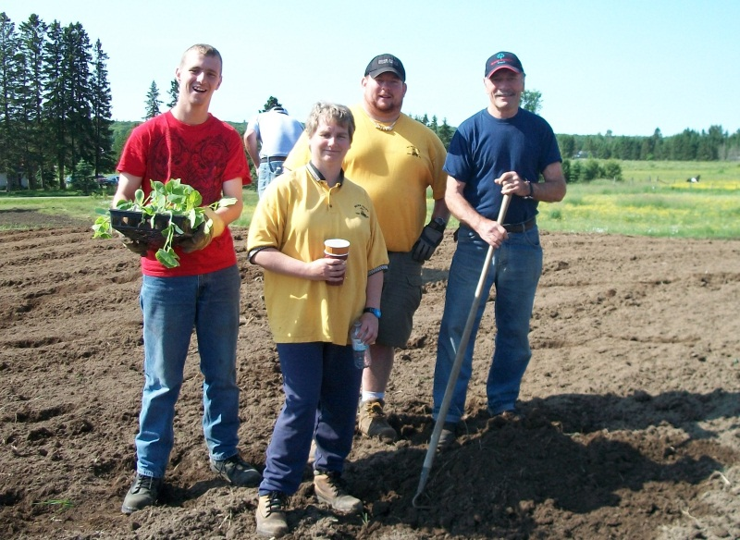

Admission to Children’s Services

Referral Process:
Referrals to Community Living South Muskoka for children’s services come from a variety of sources including parents, physicians, child care settings, school personnel, case workers from community agencies, speech and language pathologists, among others. The services provided by Community Living South Muskoka are mandated services therefore parents or legal guardians must always be aware and in agreement with the referral.

No families will be refused service on the basis of race, sex, colour, ancestry, place of origin, ethnic origin, marital status, same sex partner status, sexual orientation, age, citizenship, family status, religion or past service history.

Admission Committee:
New referrals are presented on a monthly basis to the Children’s Admissions Committee. The Admission Committee will process the application and determine the appropriate case manager to deliver service. The case manager will then set up a home visit with the family to assess eligibility, determine need, discuss concerns, share program information and develop an initial individualized support plan.

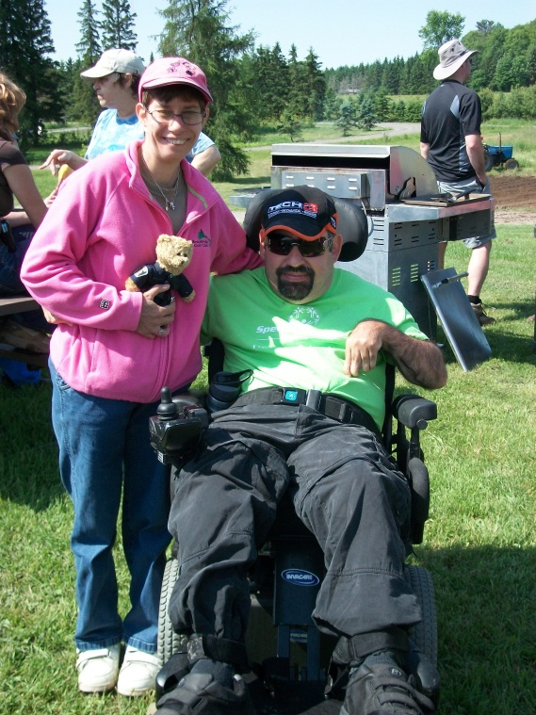
For children under 12 years of age the case manager will assist the family in attaining the appropriate eligibility documentation that will be required for future service.

For children 12 years of age and older, the referral must be supported with an assessment indicating a developmental disability.

Community Living South Muskoka will ensure all possible steps will be explored in attempting to meet the individual’s needs and desires within the service area requested.

Admission to Adult Services
All individuals requesting adult services will be referred to Community Living South Muskoka through Developmental Services Ontario – North East Region (DSO). The DSO will determine if the individual requesting support is eligible for developmental services. The services provided by Community Living South Muskoka are not mandated services. Therefore, eligibility for service does not guarantee entitlement to service.

No person will be refused service on the basis of race, sex, colour, ancestry, place of origin, ethnic origin, marital status, same sex partner status, sexual orientation, age, citizenship, family status, religion, or past service history.

Community Living South Muskoka will ensure all possible steps will be explored in attempting to meet the individual’s needs and desires within the service area requested. A service planning committee will process the application for admission to service and develop an initial individualized support plan and one page profile. The committee will also identify any areas of concern or service gaps. Based on the committee’s recommendations a decision to approve or deny the individual’s request for service will be made by the Management team.
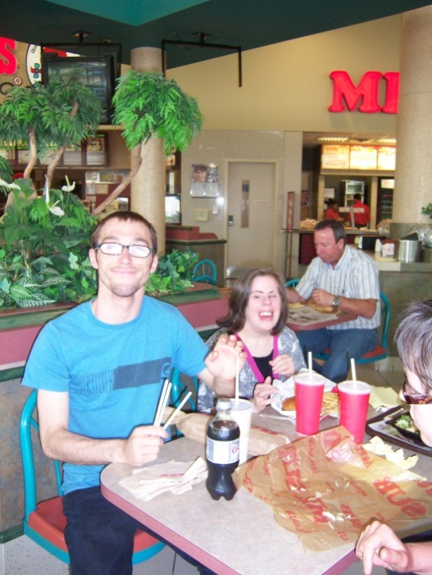
Role of Community Living South Muskoka:
- Community Living South Muskoka will complete a service availability and/or service capacity declaration when a vacancy in a service area occurs and submit the information in a timely manner to the DSO.

- Community Living South Muskoka will determine the members of the service planning committee under the leadership of the Supervisor Planning and Quality Assurance based on the area of service that has availability or capacity that has been reported to the DSO.

- The service planning committee will meet with the DSO to receive the non-identifying information of the prospective applicants. Based on the information provided the service planning committee will review the prospective applicants brought forward by the DSO and determine the best potential match to the service availability.

- Once a potential match is confirmed by the applicant and Community Living South Muskoka, and the identifying documentation (as identified in item 9 of the role of the DSO) has been received from the DSO, the Service Planning Committee directs an initial service planning meeting to be held with the identified service areas and with potential community partner support systems and services.

At the initial service planning meeting, the service partners will determine the community support system that will be required to assist the individual in the admission process and to assure the success of the match to service. Careful consideration should be given to sequential service planning and additional supports required within the service capacity. Various roles of community partners can be determined as the foundation for the development of the ongoing Individual Support Plan.

- After the initial service planning meeting, Community Living South Muskoka will invite the individual and/or their family, service partners and the DSO as required to meet to a Service Admission meeting to address the following:
  - Development of a support plan for the individual including the need for clinical supports;
  - Development of a one page profile and individual support agreement to outline the wishes, support needs and goals of the individual and define mutual service delivery expectations;
  - Ensure that any financial arrangements such as ODSP are at their correct levels or in place if an accommodation service is requested;
  - Required consents have been determined and signed;
  - Create an orientation plan to the service area(s) including meetings with peers that attend the identified service area(s);
  - The individual’s and family’s rights, responsibilities, and involvement have been discussed and documented;
  - Service area charts/recording systems/medication sheets/ person directed planning tools are set up and in place for the individual.
  - Determine any issues or concerns or service gaps that need to be resolved
  - Establish a timeline for service delivery to commence.

The service planning committee reviews the results of the Service Admission meeting and brings forward a final recommendation of approval of acceptance that the match is good or determines that match is not appropriate. The committee can also make recommendations for additional resources or supports that would improve effectiveness of the match. The final service recommendations are brought to the Admission and Discharge Committee.

- The Admission and Discharge Committee will review the recommendations of the service planning committee and provide final approval or denial of the individual’s request for service. If an individual is denied and found unsuitable in the matching process this is brought back to the DSO for consideration of the next prospective candidate that was identified though the community-based prioritization process and the process begins again with a new prospective candidate. Alternatively, if the needs of the individual exceed the resources and supports available by Community Living South Muskoka and the community support system the Chief Executive Officer or designate will review the recommendations with the DSO and Ministry of Community and Social Services if deemed appropriate.

- Once approved or denied by the Admission and Discharge committee, an admission date will be finalized and the DSO will be notified of the decision.

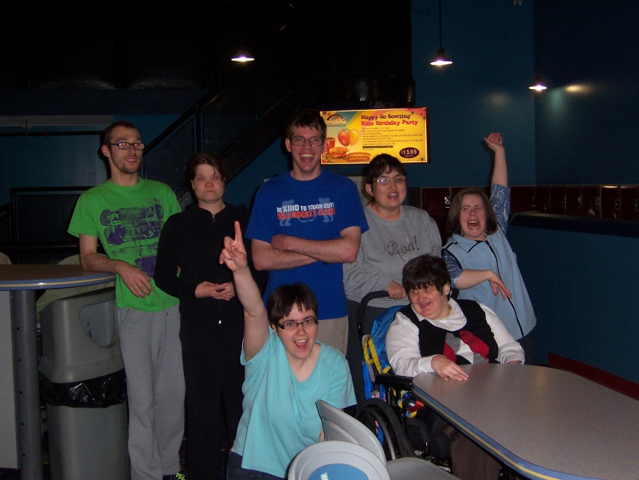

Individual Support Plans
An Individual Support Plan Agreement will be developed with each individual served by Community Living South Muskoka. The Individual Support Plan Agreement will clearly identify the role and commitment of each party and provide continuity of support to the individual. Parties to the Individual Support Agreement include: Community Living South Muskoka, the individual, family/guardian, other persons making a contribution, or other agencies.

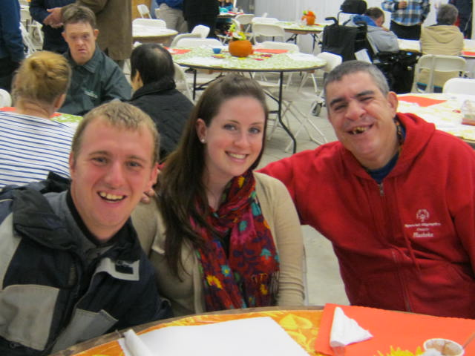
An Individual Support Plan Agreement clarifies the roles of all parties and identifies the commitments and contributions that each party will make toward the supports and services to be provided and other relevant information. An Individual Support Plan Agreement is not a replacement of or alternative to the Person Directed Planning process. The Individual Support Plan Agreement reflects the goals and interests of the individual as outlined in the person directed plan and other relevant resources such as the menu of services and are utilized to assist in the development of the Individual Support agreement.

The Individual Support Plan Agreement must be reviewed at least annually in conjunction with the person directed planning process. The Initial Individual Support Plan Agreement will be completed within ninety (90) days of admission and in conjunction with the first person directed plan. The Individual Support Plan Agreement may be reviewed or amended prior to the person directed planning process based on an expressed concern by one of the parties or a change in circumstances.

Person Directed Planning
Person Directed Planning is the cornerstone of Community Living South Muskoka’s efforts to ensure the co-ordination and facilitation of opportunities for positive experiences, outcomes and preferences as identified by the person as being important. People’s individual plans lead to person centered and person directed services and supports. People shall have control over the decisions affecting their lives and shall be the unique focus in the planning, development and delivery of their services and supports.
People shall direct the development of their plan and/or are supported to do so.

Person-directed plans shall include the person’s vision for their life, goals, and action steps designed to achieve those goals, and methods to achieve the desired outcomes. Person-directed plans shall be reviewed at least every six (6) months.

Language used in the planning process and in any planning documents must be respectful of the person and reflect personal outcome measures

Core elements of planning process include:
  - The individual is the driving force of the planning process.
  - The individual chooses who they want to be involved in the process. Family and friends are full partners in the planning process.
  - Individuals have interests and gifts that provide a valued role for them in the community.
  - Individuals desire and have the ability to gain and maintain mutually satisfying relationships.
  - Continual listening, learning and action will help the person get what they want in their life.

Community Living South Muskoka adheres to explicit set of beliefs and values concerning people with disabilities, services and communities. At the heart of all the planning approaches is the belief that every single individual has their own life to lead, a life that is right for them. We promote ourselves as a learning culture agency, continuously learning about the people we support and putting our learning into action. There are several tools that assist in this learning. The main tools used to promote our learning culture include:
- Important To/For the person
- What’s Working/Not Working
- Matching Staff
- Communication Chart
- The Learning Log

Abuse
Community Living – South Muskoka is committed to providing a safe and respectful environment for individuals we support. Community Living – South Muskoka will not tolerate abuse or mistreatment of any individual receiving service. Every individual has the right to protection from harm, and if harmed, the right to immediate support, protection, treatment and confidentiality. Any incidents must be reported immediately, promptly, and corrective action taken.

All persons involved with Community Living South Muskoka will be informed of this policy in a manner which will provide them with an understanding of the intent and responsibilities. All employees, volunteers, and board members who have direct contact with individuals supported by Community Living South Muskoka will be trained on the abuse policy and demonstrate an awareness of what steps to take when reporting abuse. All individuals who receive service will be made aware of the policy in a way to help them best understand what abuse is and how to report abuse. All employees and individuals supported are required to review the abuse policy annually.

All persons involved with the Association will be empowered to make complaints without fear of consequences. As outlined in Regulation 299/10, situations where there is an allegation of abuse or reasonable suspicion of abuse of a person over the age of 18 police must be called to investigate. No internal investigation will be conducted until the police have concluded their investigation or police have given permission for the agency to conduct an internal review. In the case of alleged child abuse, it must be reported to the local children’s aid society (Family Youth and Child Services of Muskoka) immediately.

Anyone may have suspicions of abuse as a result of the appearance or behaviour of a person. In some situations, the abuse may be clearly recognized. In other situations, there may be questions as to whether possible abuse has occurred. In reporting abuse, all persons must understand what constitutes a reasonable suspicion of abuse. Once you feel there is reasonable suspicion, report your concerns immediately to your supervisor or On-Call Supervisor, who will contact the Director of the Service Area or designate. The Director will then determine if the police should be called immediately and no internal interviewing or investigation is to take place until such time as the police investigation is complete. The following are definitions designed to assist in determining abuse:

Definitions
  - Abuse:
Abuse is any intentional act or situation which may be physical, verbal, sexual or psychological in nature, which demeans, harms, or infringes on personal rights or dignity or places an individual at risk to personal health and safety; doing nothing to stop someone from harming another person
  - Physical Abuse:
An act of physical aggression such as hitting, slapping, punching, kicking, burning, pushing, pulling, shoving; threats to harm another person
  - Sexual Abuse:
Unwanted sexual activity by anyone, sexual exploitation
  - Psychological Abuse:
Includes threats, destruction of property, withholding normal social interaction/contact,
  - Emotional Abuse:
Belittling, degrading, criticizing, undermining and attacks on self esteem
  - Financial or Material Abuse:
Using a person’s money or belongings without his/her knowledge or permission
  - Mistreatment/Neglect:
Any act that is disrespectful or demeaning to an individual; punishment of an individual in service by another individual and either condoned or instigated by staff; requiring or forcing an individual to assume an uncomfortable position i.e. kneeling, squatting, etc; requiring or forcing an individual to repeat physical movements; harsh or degrading verbal punishment; deprivation of basic needs, withdrawal of food, shelter, warmth; profanity toward an individual.
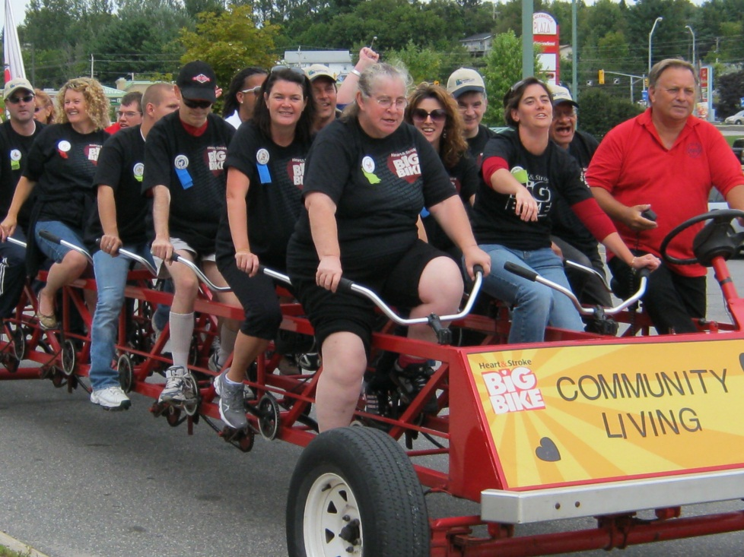

Complaint/Feedback Process
Every individual, family member, family home provider, respite provider, and relief provider is to be informed of and provided with opportunities for expressing viewpoints, concerns and complaints.

“Feedback” may be positive or negative and is related to the services and/or supports that are provided by Community Living South Muskoka. Feedback may be solicited or unsolicited from the individual receiving support or care provider.

“Complaint” is an expression of dissatisfaction related to the services and/or supports that are provided by Community Living South Muskoka. A complaint may be expressed by the individual receiving support or a person acting on their behalf, or by the general public, regarding the services and supports that are provided by the service agency. A complaint may be made formally or informally.

Individuals and their families expect services that are seamless, trustworthy, attentive using resourceful solutions. Community Living South Muskoka employees will hear out the customer, ease the tension, act to improve the situation and leave a positive impression with the individual and their families whenever possible.

Confidentiality
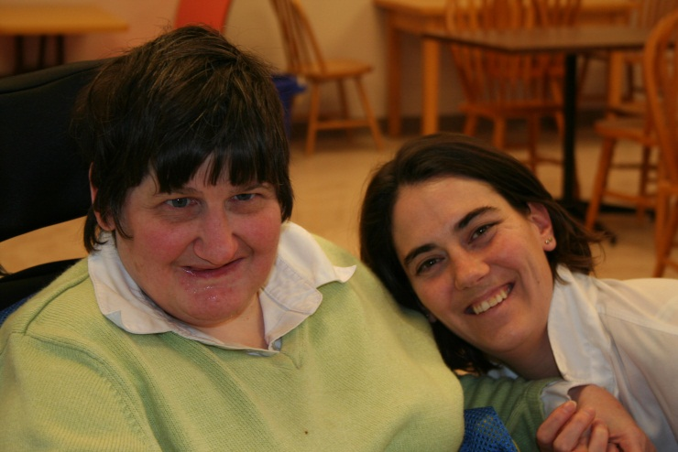
All employees, care providers, and volunteers are entrusted with information regarding the people supported by Community Living South Muskoka, their families, and the business of Community Living South Muskoka. All employees, care providers, and volunteers are required to maintain complete confidentiality regarding all information relating to service delivery and support, personnel matters and the business of the Community Living South Muskoka. All employees, care providers, and volunteers are required to read and sign the Confidentiality Policy.

People receiving support & their families: Anything that names or identifies a person as a present or past program participant or applicant, which suggests or describes their condition, health status, or living or working circumstances or address is confidential. Such information is considered personal and confidential regardless of the source, including whether it is obtained intentionally or unintentionally; from the person, his family or partner, or from another source; or through oral, written, or electronic medium. Any and all records obtained or kept in any of the above ways is confidential.

Financial & Accounting: Information as relates to the business of Community Living South Muskoka including but not limited to bank information, payment, employee, care providers, and volunteer information, payroll information, employee benefit information, financial disclosure, individualized funding arrangements, and/or any information as deemed to violate trust.

Violations of this policy, in part or whole, will be considered grounds for disciplinary or other actions. Sanctions may include reprimand, prohibition from further access to information, or termination of employment.
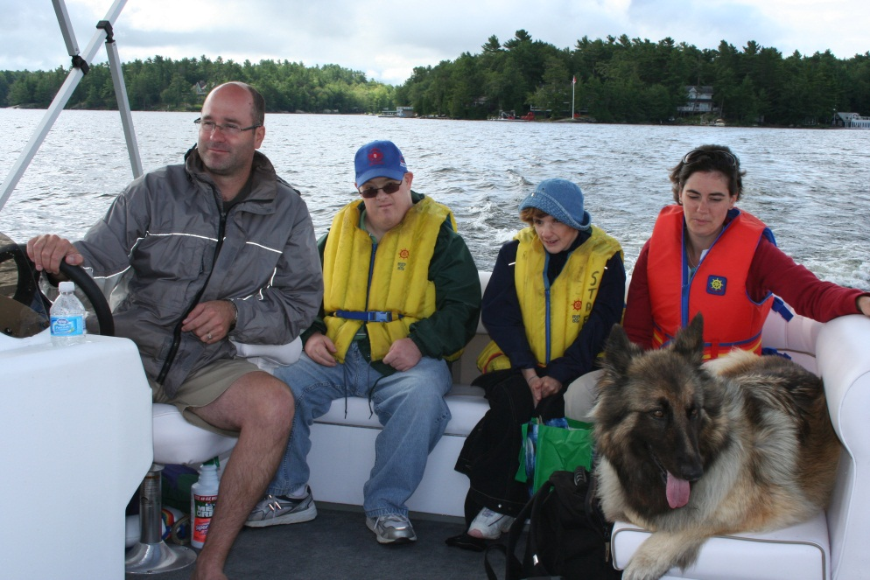

Privacy, Consent to Collection, Use or Disclosure of Information
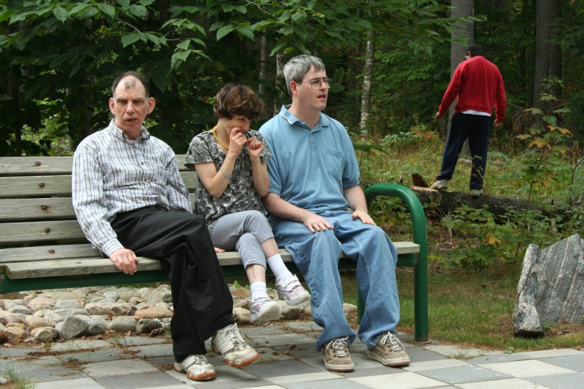
Client Information Management Systems (CIMS) and Community Living South Muskoka recognizes the importance of privacy and the sensitivity of Personal Health Information (“PHI”). We are committed to protecting any information that we hold. This Privacy Policy outlines how we manage Personal Health Information and safeguard privacy. Any reference to “your information: means your Personal Health Information as defined by PHIPA.

PHIPA is the Law
Effective November 1, 2004, Health Information Custodians in the Ontario health care system that collects uses or discloses personal health information must comply with the Personal Health Information Protection Act, 2004.

Community Living South Muskoka is a Health Information Custodian and is responsible for the personal health information we collect, use, maintain and disclose, as set out in this Policy.

1.0 What Information Do We Collect from You?
- We will ask you to give us whatever information about your health and your family’s health that we need to care for you.
- We will collect information from you for the following purposes, which are our “main activities”: caring for you, administration of this agency and the health care system, teaching, limited research, statistics and complying with legal and regulatory requirements.
- We will either directly tell you why we are collecting your information or we will post a notice or give you information that describes why we are collecting your information.
- We may collect information about you indirectly (i.e. from other health care providers or from your family and friends) if necessary to provide you with care, when you cannot provide the information yourself or cannot consent to providing the information yourself.
2.0 How Do We Use Your Information?
- Your information is given to your caregivers in the Client Information Management System agencies to be used to provide support for you.
- Our managers, employees, professional staff, volunteers and students are trained and understand that your information is private and can only be used or accessed to care for you or carry out our main activities.
- People who have a contract to provide services to Community Living South Muskoka (such as fixing equipment, maintaining computers) may have access to your information, and we take steps through our contracts to make sure this information is kept private.
- Unless we have your consent to use your information for research purposes, your information will only be used for research if the strict process (ensuring both privacy and ethical conduct) in PHIPA is followed.
If we use your information for any purpose other than our main activities, we will ask your permission.
3.0 When Will We Disclose Your Information?
- Unless you tell us not to, we will disclose your information to other health care providers in the “Circle of Care” who need to know this information to provide you with care or help to provide you with care. The “Circle of Care” includes health care professionals, other hospitals, pharmacies, laboratories, ambulance service, nursing homes, Community Care Access Centre’s (CCAC's) and home service providers who provide you with health care services.
- Sometimes the law requires us to disclose information about you. We will only disclose your information when the law requires or permits us to do so.

4.0 Getting Your Consent
4.1 Your consent to our collection, use or disclosure of your information may be implied or
express. In certain circumstances we will always ask for your express (written) consent:

- Where we are disclosing your information to someone who is not a Health Information Custodian (i.e., to your insurer, employer, WSIB, CAS, lawyer, etc); and
- Where we are disclosing your information to someone who is a Health Information Custodian but for purposes other than providing you with health care (e.g. a school nurse).

4.2 Where we obtain your implied consent, you will have been provided with a notice
(either posted in a place where you are likely to see it or directly given to you) and an
opportunity to withhold your consent.
- You may withdraw or limit your consent at any time, unless doing so prevents us from recording the information we require from you by law or under professional standards. You can give an express (written) instruction that specific information not be used or disclosed.

4.3 We may sometimes collect use or disclose your personal information without your
consent in limited instances that are expressly permitted by PHIPA. For example,
some statutes require disclosure of your information, such as the Coroners Act and the
Vital Statistics Act and Child and Family Services Act.

5.0 Retaining Your Information and Disposing Your Information
We retain your information at Community Living South Muskoka or in premises controlled by Community Living South Muskoka and the Client Information Management System in a secure manner and keep it for as long as necessary to fulfill the purposes for which it was collected, or as required by law.

Community Living South Muskoka has a policy in place to address the retention and destruction of records in the organization. This policy sets out minimum and maximum retention periods and complies with applicable laws governing retention of information. Where you have requested access to a record with your information, we will retain that record until your access request is exhausted.

6.0 Accuracy Of Your Information
We take reasonable steps to ensure your information is as accurate, complete and up-to-date as necessary on collection. We will not routinely update information in our control unless routine updates are necessary to fulfill the purposes for which the information was collected. We take reasonable steps to ensure that any information that is used by Community Living South Muskoka an ongoing basis, including any information that is routinely disclosed to others under this Policy, is accurate, complete and up-to-date. Where we know that information is not accurate, complete or up-to-date, this fact will be indicated at the time of use or disclosure.
7.0 Security Of Your Information
Security safeguards protect your information, in the custody or control of Community Living South Muskoka and the Client Information Management Systems group. These security safeguards are in keeping with industry standards and are designed to protect your information against loss or theft as well as unauthorized access, disclosure, copying, use or modification. Among the steps we take to protect your information are:

- premises security, including locked filing cabinets where cabinets are located in publicly accessible areas;
- restricted access to information stored electronically;
- using technological safeguards like security software and firewalls to prevent hacking or unauthorized computer access; and
- internal password and security policies

Community Living South Muskoka is aware of the importance of keeping your information confidential. As a condition of employment or obtaining/maintaining privileges, all staff are required to sign a Confidentiality Agreement, which is reviewed and renewed annually. We will notify you at the first reasonable opportunity if your information is lost, stolen, or subject to unauthorized access, disclosure, copying, use or modification.

8.0 How To Access Your Information
You can request access to any records in our custody or control that contain your information by writing to our Director of Administrative Services who is our Privacy Officer. The guidelines for processing these requests are available on request. You will receive at least a preliminary response from the Director of Administration Services who is our Privacy Officer within 30 days, and a full response within 60 days.

If our Privacy Officer refuses you access to your records, there will be a reason given, and you will also be notified of your right to complain to the Information Privacy Commissioner of Ontario (IPC). You are also entitled to challenge the accuracy or completeness of any of your information in our custody or control. Requests to challenge and/or change your information must be directed to our Director of Administrative Services who is our Privacy Officer, in writing. You will receive at least a preliminary response from our Privacy Officer within 30 days, and a full response within 60 days.

We will notify you at the first reasonable opportunity if your information is lost, stolen, or subject to unauthorized access, disclosure, copying, use or modification.

9.0 Challenging Compliance
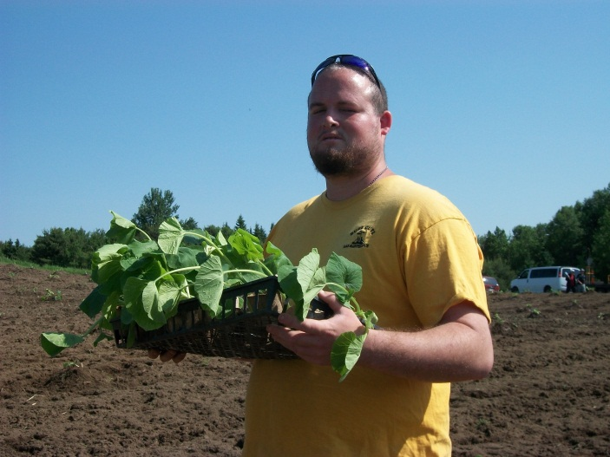
You are entitled to challenge our compliance with the principles set out in this Policy. Please direct any challenge in writing to our Director of Administrative Services who is our Privacy Officer.
Anyone who submits a written complaint, challenge or inquiry will be given a written copy of our procedures governing such complaints, challenges and inquiries.
We will investigate all complaints received. If a complaint is found to have merit, we will take appropriate measures to address the complaint, including amending our policies and practices relating to management of your information.

10.0 Compliance With This Policy
All of our agents (employees, managers, volunteers, students, and professional staff members) are required to know and comply with this Policy. Annual confirmation of compliance is suggested. Any breach of this Policy may result in disciplinary action, including:

- for agents (staff) and volunteers, suspension, demotion, and termination; and
- for professional staff members, restriction or revocation of privileges, in whole or in part.

Agents (staff) may only use your information as permitted by Community Living South Muskoka and within the same legal limitations imposed. All agents (staff) must notify the organization at the first reasonable opportunity if your information is lost, stolen or accessed without authorization.

Rights
Community Living South Muskoka will honour the rights and freedoms of every individual it supports as guaranteed under the Canadian Charter of Rights and Freedoms and the Human Rights Code.

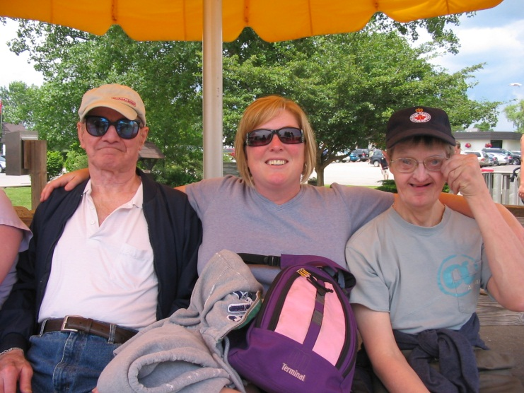
Community Living South Muskoka will ensure that all individuals are aware of their rights and provide supports. Community Living South Muskoka will advocate for and support individuals in advocating for themselves.

All staff will respect the rights of individuals they are supporting. Staff will ensure individuals are made aware of any risks and responsibilities associated with exercising a right. Staff will identify any restrictions to the rights of individuals and develop a support plan to be presented to the Rights Committee for the reduction or removal of the restriction.

1. Community Living South Muskoka will provide information about rights to individuals in a manner which is clear and understandable.
1.1 Rights training will be provided annually, or as requested, to individuals, staff,
families, support workers and volunteers.
1.2 Staff will ensure that individual’s rights are incorporated in all aspects of support.

- Community Living South Muskoka will assist individuals in the pursuit and discovery of
what rights are most important to them by providing activities and supports that will
enable individuals to explore all aspects of rights and related responsibilities.
2.1 Staff will ensure that a risk analysis is completed and a support plan developed to
enable individuals to pursue their rights.
  - The Director - Services and Supports will facilitate and ensure rights audits are
conducted as part of the individual planning process. Random rights audits may
also be conducted.

- Individuals who believe their rights are being compromised, denied or violated by
Community Living South Muskoka may appeal the rights restriction to the Rights
Committee of Community Living South Muskoka who shall give due process to hearing
and determining the consideration of that appeal.
3.1 An individual and/or a support worker may bring forward a request to the Rights
Committee to review a perceived rights restriction.

3.2 The Rights Committee has been established by the Board of Directors to ensure
that the following elements of daily life are respected as rights for the individuals
we support. These will include but are not limited to: Right to the least intrusive
and restrictive environments and support ;
- Freedom of unrestricted movement;
- Free access to telephones;
- Confidentiality;
- Access to his/her money and possessions;
- Right to sexual activity and personal relationships;
- Right to refuse treatment;
- Right to due process;
- Freedom from intrusive methods of treatment and training, and
- Being free from abuse and neglect.

4. Rights limitations or restrictions cannot be imposed without consent and approval of the
Rights Committee or in accordance with any legal order or requirement.

- If or when limitations or restrictions are imposed, Community Living South Muskoka will
provide supports and services to restore rights. Unless a right restriction is in place due to a
legal order or requirement, the rights restriction shall be considered temporary.

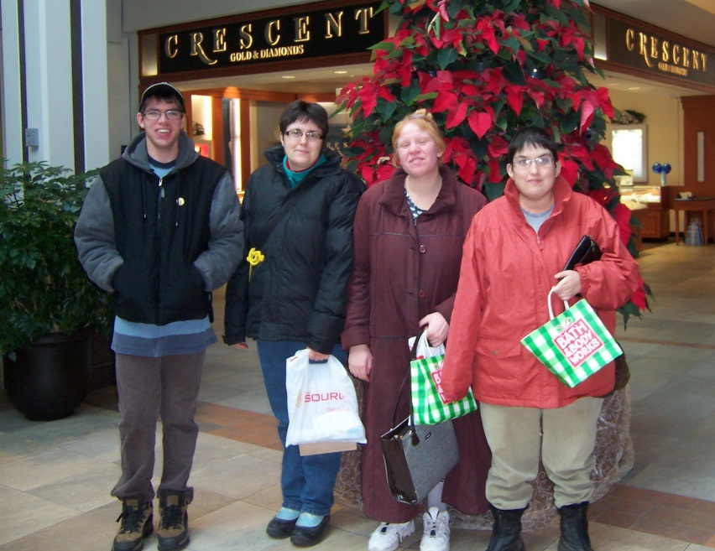

INDIVIDUAL SUPPORT PLAN AGREEMENT

SECTION A: INDIVIDUAL PROFILE

NAME: ______________________________________________D.O.B. _________________________
ADDRESS: _______________________POSTAL CODE: ___________PHONE NO:_______________

NEXT OF KIN (FAMILY/EMERGENCY CONTACT): _____________________PHONE NO: _______________

SECTION B: INDIVIDUAL SUPPORT PLAN Initial Plan Annual

For a person receiving support from Community Living South Muskoka, this ISP meets the requirements of Ontario Regulation 299/10 – Quality Assurance Measures, when accompanied by a current Person-Directed Plan (PDP) and Behaviour Support Plan (BSP)* (if applicable)

PARTICIPANT NAME: ___________________________________________________________

DATE OF INDIVIDUAL SUPPORT MEETING: _________________________________________

DATE OF CURRENT PERSON-DIRECTED PLAN: _____________________________________

DATE OF CURRENT BEHAVIOUR SUPPORT PLAN* (if applicable): ______________________

DATE OF ABUSE PREVENTION AWARENESS TRAINING ______________________________

DATE OF NEXT REVIEW:

PERSONS INVOLVED IN THE DEVELOPMENT OF THIS PLAN:
NAME | RELATIONSHIP TO PARTICIPANT

NECESSARY SAFEGUARDS TO PROTECT THE HEALTH AND SAFETY OF PARTICIPANT Please List and attach documents as applicable (Specific Protocols, Bathing Protocols, Independence Rating/Level of Supervision, Level of Support Needed or Requested for Managing Money, Self-Administration of Medication, Refusal and/or Difficulty Attending Medical Appointments, ADSS and SIS Summary reports etc.):

___________________________________________________________________________________

___________________________________________________________________________________

___________________________________________________________________________________

___________________________________________________________________________________

___________________________________________________________________________________

SECTION C: MANNER IN WHICH SERVICES AND SUPPORTS ARE TO BE PROVIDED

AREA OF SERVICE | DESCRIPTION OF SERVICE(S) PROVIDED INCLUDING DAYS, TIMES AND LOCATIONS WHERE SUPPORT IS PROVIDED
Accommodation | Service(s):  Location:  Day:  Time: Hours per Week:
Long Term Goals: |  | Related Tasks: | Outcome:
Short Term Goals: |  | Related Tasks: | Outcome:

Community Living Skills | Service(s):  Location:  Day:  Time: Hours per Week:
Long Term Goals: |  | Related Tasks: | Outcome:
Short Term Goals: |  | Related Tasks: | Outcome:

AREA OF SERVICE | DESCRIPTION OF SERVICE(S) PROVIDED INCLUDING DAYS, TIMES AND LOCATIONS WHERE SUPPORT IS PROVIDED
Crisis Prevention/  Resolution | Service(s):  Location:  Day:  Time: Hours per Week:
Long Term Goals: |  | Related Tasks: | Outcome:
Short Term Goals: |  | Related Tasks: | Outcome:

Life Long Learning | Service(s):  Location:  Day:  Time: Hours per Week:
Long Term Goals: |  | Related Tasks: | Outcome:
Short Term Goals: |  | Related Tasks: | Outcome:

Finances | Service(s):  Location:  Day:  Time: Hours per Week:
Long Term Goals: |  | Related Tasks: | Outcome:
Short Term Goals: |  | Related Tasks: | Outcome:

AREA OF SERVICE | DESCRIPTION OF SERVICE(S) PROVIDED INCLUDING DAYS, TIMES AND LOCATIONS WHERE SUPPORT IS PROVIDED
Health and Medical | Service(s):  Location:  Day:  Time: Hours per Week:
Long Term Goals: |  | Related Tasks: | Outcome:
Short Term Goals: |  | Related Tasks: | Outcome:

Social Recreation Leisure | Service(s):  Location:  Day:  Time: Hours per Week:
Long Term Goals: |  | Related Tasks: | Outcome:
Short Term Goals: |  | Related Tasks: | Outcome:

Respite | Service(s):  Location:  Day:  Time: Hours per Week:
Long Term Goals: |  | Related Tasks: | Outcome:
Short Term Goals: |  | Related Tasks: | Outcome:

AREA OF SERVICE | DESCRIPTION OF SERVICE(S) PROVIDED INCLUDING DAYS, TIMES AND LOCATIONS WHERE SUPPORT IS PROVIDED
Emotional Supports | Service(s):  Location:  Day:  Time: Hours per Week:
Long Term Goals: |  | Related Tasks: | Outcome:
Short Term Goals: |  | Related Tasks: | Outcome:
Therapeutic Partnerships  (clinical supports) | Service(s):  Location:  Day:  Time: Hours per Week:
Long Term Goals: |  | Related Tasks: | Outcome:
Short Term Goals: |  | Related Tasks: | Outcome:
Employment Services | Service(s):  Location:  Day:  Time: Hours per Week
Long Term Goals: |  | Related Tasks: | Outcome:
Short Term Goals: |  | Related Tasks: | Outcome:

AREA OF SERVICE | DESCRIPTION OF SERVICE(S) PROVIDED INCLUDING DAYS, TIMES AND LOCATIONS WHERE SUPPORT IS PROVIDED
Planning | Service(s):  Day:  Time: Hours per Week:  Location:
 | Long Term Goals: | Related Tasks: | Outcome:
 | Short Term Goals: | Related Tasks: | Outcome:
Other | Service(s):  Day:  Time: Hours per Week:  Location:
 | Long Term Goals: | Related Tasks: | Outcome:
 | Short Term Goals: | Related Tasks: | Outcome:

OTHER COMMUNITY RESOURCES THAT MAY BE REQUIRED AND/OR ACCESSED TO ENSURE COMMUNITY INCLUSION (Medical, Vocational, Recreational, Cultural, Religious/Spiritual and Social):

AGENCY (Service) | CONTACT PERSON | TELEPHONE | CL-SM staff connections

CIRCUMSTANCES WHEN, IF ANY, PARTICIPANT WOULD PERMIT THE INFORMATION IN THIS ISP TO BE SHARED WITH PERSONS OTHER THAN STAFF MEMBERS AND THE PERSONS WITH WHOM IT MAY BE SHARED:

___________________________________________________________________________________

___________________________________________________________________________________

___________________________________________________________________________________

___________________________________________________________________________________

To be signed ONLY after Supervisory review

I HAVE BEEN SUPPORTED TO PARTICIPATE AS FULLY AS POSSIBLE IN THE DEVELOPMENT AND ANNUAL REVIEW OF MY INDIVIDUAL SUPPORT PLAN.

PARTICIPANT SIGNATURE:_____________________ DATE: ______________________________

SECTION D: CONFIDENTIALITY AND INFORMATION SHARING

I, _____________________________________ or _______________________________ (on my behalf) give permission for the information in my Individual Support Plan Agreement to be shared with employees of Community Living South Muskoka who have an active role in providing my supports and services. Any further sharing of this information with other agency’s or services will require my signed consent.

__________________________________ __________________________________
Individual’s Signature Date
(or person acting on their behalf)

___________________________________ ___________________________________
Family’s Signature Date

___________________________________ ___________________________________
Supervisor Signature Date

___________________________________ ___________________________________
Director Signature Date

SECTION E: AREA OF SERVICE GLOSSARY

Accommodation | Goals related to housing and/or residential programs
Community Living Skills | Goals related to the development of community awareness, personal safety, personal hygiene and grooming, money management, home management and cooperative living
Crisis Prevention/Resolution | Goals that relate to crisis management skills
Life Long Learning | Goals related to school and training programs
Finances | Goals related to government funding, income, budget, etc. to meet the needs for daily living or supplement the cost of equipment, services or programs
Health and Medical | Goals related to health care services, mental health supports, counseling and assessments
Social-Recreation/Leisure | Goals related to socialization activities and personal fulfillment activities
Respite | Goals related to alternative accommodation and/or alternative caregiver
Emotional Supports  (supportive counseling) | Goals related to maintenance and enhancement of quality of life through development of prevention strategies, providing support and monitoring progress
Therapeutic Partnerships  (Clinical Supports) | Goals related to specialized needs such as behavioural programming, interpersonal skills training, sexuality counseling, family or individual counseling and psychological assessments
Employment Services | Goals related to employment including pre-employment activities, volunteer work, job supports
Other | Goals that are exceptional and cannot be categorized under standardized headings. Please specify.

Community Living South Muskoka
Complaint/Feedback Co-ordinator
15 Depot Drive
Bracebridge, Ontario
P1L 0A1

Phone: 705-645-5494
Fax: 705-645-4621
Email: info@clsm.on.ca
Community Living South Muskoka promotes a welcoming inclusive community where all are encouraged to reach their potential.

A welcoming inclusive community is one that believes:
- Every person is valued
- Every person has a need for love, friendship, and belonging to ensure their well being and a meaningful life
- Every person is entitled to acceptance and respect
- Every person has the right to reach their potential
- In promoting creativity, flexibility and choice as a means of developing personal and community growth
- With every right there is an inherent risk
- With every opportunity there is an inherent risk
- In ensuring for all, full accessibility to information, services and resources
- Growing and learning are part of the personal responsibilities
If you are making a complaint please tell us how this has affected you. What can we do to put things right?

Your name:
Address:
Contact number:

Tell Us
What You Think
Community Living South Muskoka

Telephone: 705-645-5494
Website: www.clsm.on.ca

Providing service excellence by responding to the voice of our customers.

To tell us about our services you can:
1. Speak directly to the person providing services to you. This is often the best way of resolving any problems.
2. Tell us what you think by completing this form and submitting it to us.
3. Speak or write to the Supervisor of the Service area.
4. If your issue is not resolved, contact The Director of the Service area. If it continues to be unresolved contact the Chief Executive Officer.
5. If you want to email your feedback or complaint to us, you can contact us at info@clsm.on.ca and we will ensure the right person receives the information.

This leaflet gives you information on where to go to compliment, raise concerns or make a complaint.
Community Living South Muskoka wants to offer the best possible services.
We can learn from you and change how we do things if you — tell us
When we get it right — compliment us
When we don’t—voice your concern or make a complaint
We will get back to you when you contact us. We want to reassure you that the service you get will not be affected if you voice concerns or make a complaint.

Complaint/Feedback

Investigation Process

Your feedback is taken very seriously. All concerns will be investigated to improve service. There are three levels to our complaint/feedback process:

1. Dealing Directly with the Person
The first attempt to address the issue should be with the person responsible for providing service to the individual. The person providing the service may not be aware of the issue and needs the opportunity to address the concern and make changes where appropriate.
2. Requesting Informal Action and Resolution
The purpose of this step is to provide a means to obtain information, voice the concern, and develop a way of dealing with the problem with the assistance of the service area’s immediate Supervisor achieving an informal resolution. Where attempts to achieve an informal resolution of the concern or complaint are unsuccessful or inappropriate, a formal complaint/concern may be filed which shall result in an investigation by the Director of the Service Area or the Chief Executive Officer if warranted.

3. Filing a Formal Complaint or Concern
A formal complaint or concern can be filed directly with the Supervisor, Director or Chief Executive Officer. The complaint or concern must be submitted in writing and signed and include a description of the situation, others who may have knowledge related to the situation, if any, and the steps already taken to resolve the matter. The Chief Executive Officer or designate shall acknowledge receipt of the complaint / concern within five (5) working days to the complainant for clarification and/or further information. The Formal complaint process has five stages:
Fact Finding
The Chief Executive Officer or designate shall conduct confidential interviews with relevant parties to obtain information and clarify the details of the reported complaint or concern.
Preliminary Findings
Where the information revealed early in the investigation suggests a reasonable possibility of resolution, the Chief Executive Officer or designate may decide to propose an early resolution prior to conducting the entire investigation.
Resolution
The Chief Executive Officer or designate shall schedule meetings with the complainant, person providing service, Supervisor and Director of the service area to present and discuss the findings and conclusions of the investigation and actions to be taken to resolve the issue.
Monitoring
Follow-up should occur periodically over a minimum six (6) month period from the date of resolution.
If you prefer you can write your compliment, concern or complaint here and send it to address on this brochure.
If you give us your contact number we will call you.
Tell us about your compliment, concern or complaint:

CONSENT TO THE DISCLOSURE, TRANSMITTAL, OR EXAMINATION OF INFORMATION

I, _____________________________________of _____________________________________
Full name of person providing consent address

Hereby authorize verbal and/or written communication between authorized personnel of Community Living – South Muskoka and:
____________________________________________
Name of Agency

____________________________________________
Address
____________________________________________

regarding __________________________________ ‘s involvement in this service for the purpose
Full name of person inquired about and date of birth
of ____________________________________________________________________________.

Information to be disclosed:
____ Educational ____ Social History ____ Physiotherapy
____ Speech ____ Occupational Therapy ____ Psychological
____ Medical ____ Other – (specify) ______________________________
__________________________________________________

____________________________________________________ ________________________
Signature of: Consenting Person Custodial Parent Legal Guardian Date

____________________________________________________ ________________________
Signature of Witness Date

___________________________________________________ ________________________
Signature of: Date
Consenting Person Custodial Parent Legal Guardian

____________________________________________________ _________________________
Signature of Witness Date

If consent obtained verbally, specify details _____________________________________________________________
^{(ie: time, method, etc.)}
__________________________________________________________________________________________
This consent will expire as of ___________________________ (not to exceed twelve (12) months) or upon cancellation by the above signing authority.

YOU MAY WITHDRAW YOUR CONSENT VERBALLY OR IN WRITING AT ANY TIME

